5 Reasons to Invest in Showcase with IMAX

From an analysis of the financial projections of the Showcase, indicative ratios such as EBITDA margin, ROI, and Debt Service Coverage indicates a strong financial model. Financial models are however built on market research, historical performance and sound revenue assumptions. The follow is a short summary of a view beyond the basic analysis for a prospective investor to consider.

1: Immediate Market Monopoly by New Cinemas

2: Unmatched Product Offering

3: International Advantage

4: Superior Spending Power of Customer Base

    A: Domestic

    B: Tourist

5: Long Term Sustainability

The Showcase with IMAX is a Family Entertainment Center. Its main attraction is a state of the art nine (9) screen cineplex. This project presents several distinctive features that make this investment opportunity quite exceptional and attractive to investors. These five (5) features mitigate much of the risks involved in a startup venture.

**Lesson from Past History**

***Reason 1 to Invest:***

*Historically. New Cinema Operators enter the Bahamian market and monopolize the marketplace for long periods of time.*

From 1990-2015, the average Bahamian theater market monopoly spans7.5 years. As startling as that may sound, what’s even more astounding is how quickly it occurs. Total market consolidation starts **within 1 to 2 years of a new entry** into the industry.

Currently the sole operator, Galleria Cinemas has been in the market for 16 years (since 1999). **12 of those 16 years have been as a monopoly**. However their consolidation of the Bahamian market started within 18 months of their entry.

*Reasons for such quick consolidations and long monopolies in the Bahamas:*

1. Poor Upkeep of facilities by existing owners

2. Not staying current with technology within the film industry

3. Superior Products/ Amenities by the new operators

4. Governmental laws inhibiting foreign investment and incursions

In the last generation, Galleria Cinemas battled the previous monopoly of RND Cinemas. Galleria had the power of more screens, better amenities and a superior location with larger customer base (the largest mall in the Bahamas).Sixteen years later, outdated Galleria Cinemas’ facilities are in the same position as RND Cinemas of 1999. These are just some of the Bahamian customer commentaries:

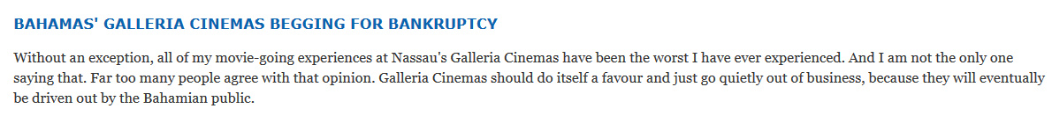

Showcase with IMAX will exploit these weakness.

**Lessons in the Present**

***Reason 2 to Invest:***

*Showcase with IMAX is entering the Bahamian Cinema industry with a superior product mix. Its sole competitor, Galleria Cinemas, has a limited offering.*

Besides having rundown facilities, Galleria only shows 2D movies, with minimal advertising.

The product mix of Showcase with IMAX is more robust:

* A Cineplex with 9 screens
* Expanded concessions with ice-cream and coffee
* Full serve restaurant with veranda
* Feature Attractions: IMAX, 4DX, VIP theater, VIP lounge
* Re-Introduction of 3D movies
* Secondary Attractions: Young Hollywood Concept with full Arcade, Party Rooms, Kids Indoor Playground

This product mix even surpasses many chains in the US let alone, Galleria Cinemas. Globally, theater chains have begun to embrace the concept that you have to be more of a destination than a just location that shows movies.

Food choices has expanded exponentially as evident is the top 5 US brands push for in theater dining and even full restaurants on property.

Building further on this extended business model is the more comprehensive secondary attractions to increase spend per head. One of the leading chain to embrace this approach was Cineplex of Canada with Xscape, their arcade and party brand.

2014 was a tough year for in the US Theater Markets yet Cineplex of Canada had record fourth quarter revenue thanks in part to this business model.

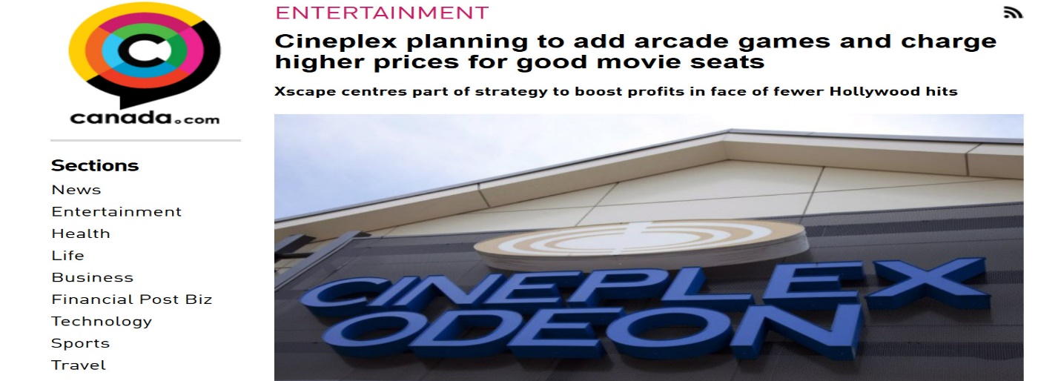Emphasizing this point is Cineplex’s changing business model:



Showcase with IMAX will have the largest arcade area in the Bahamas at almost 4000 sq. ft. Only one other company is currently serving this market.

***Reason 3 to Invest:***

***IMAX and 4DX licenses*** *have greater value and power outside of the United States than within. These licenses can then be used to dramatically shape regional markets in favor of franchisees.*

In terms of large revenue generation and high occupancy rates, the top two global brands for cinema are:

* **IMAX:** Specialize theaters with 5 story screens and incredible sound systems

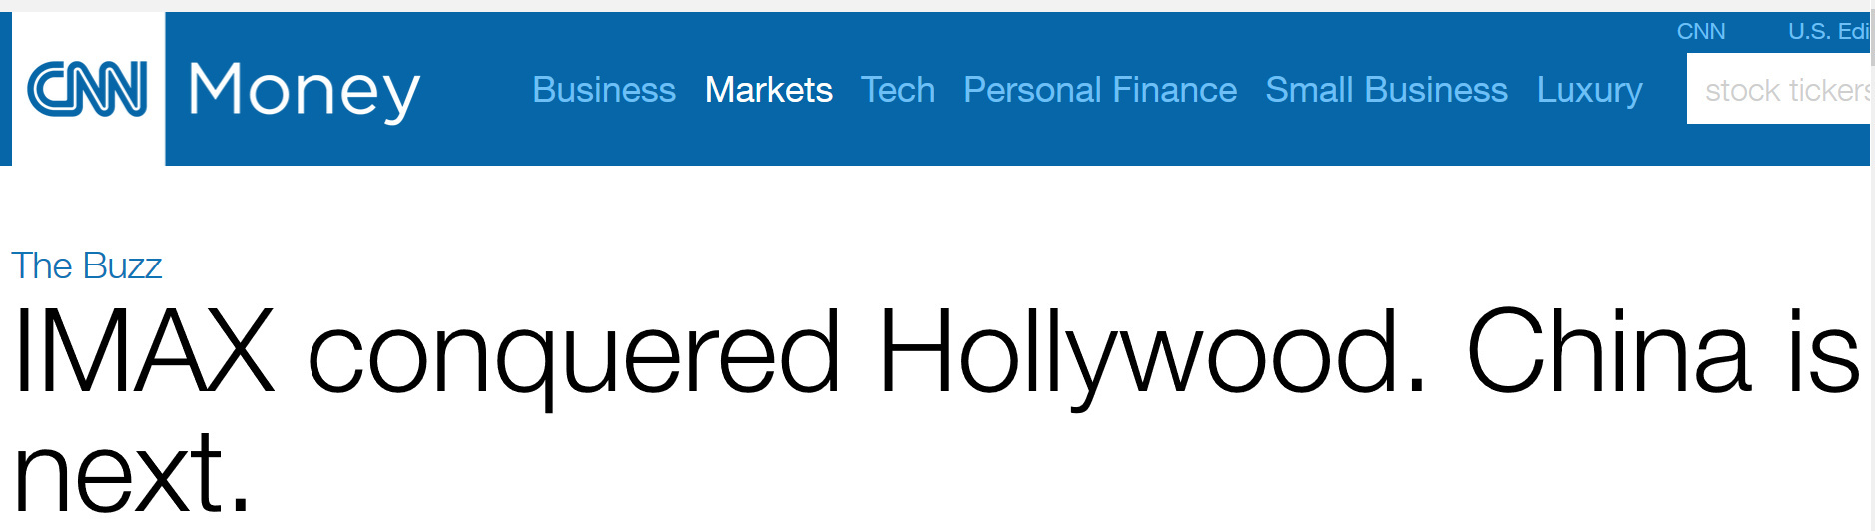

* **4DX**: Theaters with moving seats and dozens of environmental effects like water and air which add to the story telling experience of the movie.

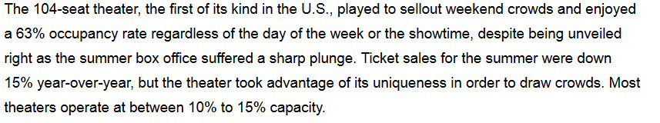

Understanding their value is a two stage process:

**Stage 1: Securing the Asset**

When theater exhibitors sign these premium brands in the US, they are given exclusive zones of operation of 3.5 miles or less.

However in the Bahamas, the Atavus Group has obtained the IMAX and 4DX licenses for the **entire island exclusively**. More importantly these are timed **exclusives of 5 years and 10 years for 4DX and IMAX respectively**. Thereafter Atavus will have rights to first refusal for additional 5 year engagements.

**Stage 2: Use of the Asset**

Application of these licenses to regional markets is profound. Think of the competitive advantage of showing an IMAX or 4DX 3D movie in a beautiful new facility versus the destitute Galleria Cinemas where the sound systems and screens haven’t changed in 16 years.

**As great as that sounds IMAX has done something even better for its network partner.**

IMAX has negotiated with studios to release Hollywood Blockbusters **EARLY** to their screens.



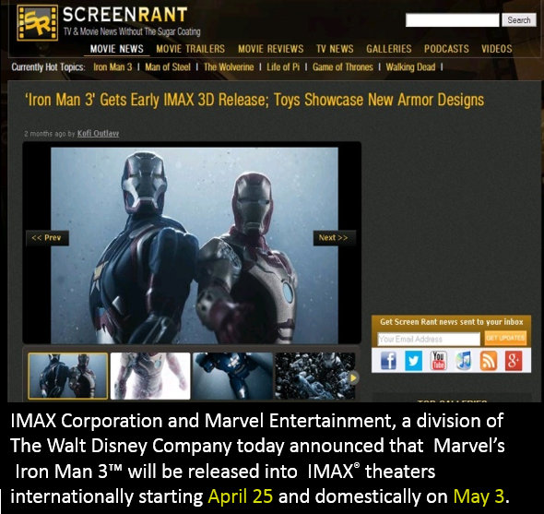



To put this into perspective, Iron Man would have come out **8 days in the exclusive IMAX format** before Galleria Cinemas could show the movie once.

Showcase has 380 IMAX seats, hence with at least 6 shows a day (even at 50% capacity) over 9,000 people would see the show.

That’s 9,000 customers and 9,000 word of mouths about the exclusive IMAX experience.

This is how to dominate a market.

***Reason 4 to Invest:***

*Atavus Group has done over* ***6 years of research*** *on the Bahamian Market. The customer base is ready, willing and able to support the Showcase with IMAX.*

**Domestic Component:**

**Customer Capacity**

From a capacity stand point, the Bahamas is one of the richest countries in the Caribbean. For a point of reference, Digicel IMAX a single screen theater in Trinidad and Tobago will be used. It is currently the largest grossing IMAX in the region.

Source: World Bank GNI per capita (formerly GNP per capita) is the gross national income:

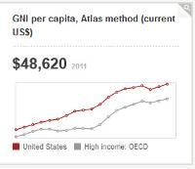 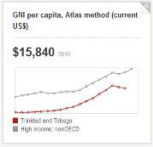 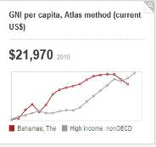

United States Trinidad and Tobago Bahamas

**Disposable Income:**

Source: Number Disposable Income Analysis (per household)

**United States of America:**

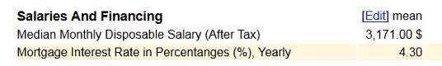

**Trinidad and Tobago:**

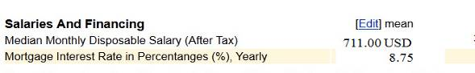

**The Bahamas**:

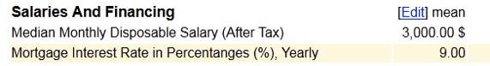

**Willingness to Spend**

Over the last five years, Bahamians have spent, on average of $400,000,000 on Dining out and Entertainment annually. This is more than they spend on Education and Bread Basket Items. When consideration is taken for the fact that there are 377,000 Bahamians, one recognizes how much they like being entertained and socializing.

**Alternative Entertainment Options**

There are no professional sports teams in the Bahamas or regular concerts. Besides the movies, there are very few entertainment choices for families. The only other choice is a bowling alley. However, for a family of four to go bowling is $102 vs $70 to go to the movies. Hence substitutability, in the Bahamas, for cinema is low.

**Expansion of the Customer Base**

The Showcase with IMAX will have a tremendous opportunity not only to capture the existing customer base but expand the same.

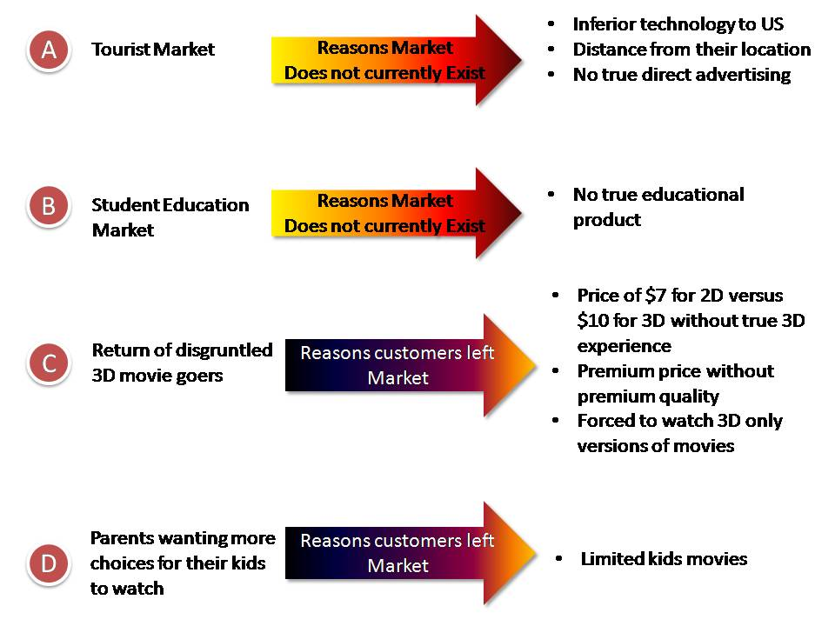

**Only 2D Movies are shown in the Bahamas**

**Poor quality of Galleria’s presentation**

**Due to old and inferior equipment**

**Tourist Component:**

The tourist component of the customer base is important when considering the facility’s close proximity to Baha Mar. Baha Mar’s target market is split between the North America and Asia. One of the equity partners in the mega resort is based in China.

The governments of both countries have recently signed agreement to start direct flights out of major Asian cities. These tourists travel further hence they usually stay longer (on average 13 days) and spend the most of all global travelers ($164.8 billion in 2014).

Besides luxury shopping, one of the things they do is watch movies when abroad. Why? High censorship in China limit US movie releases. These tourist prefer three type of movies.

1. 3D movies
2. IMAX movies
3. 4DX technology

The Showcase with IMAX will be the only theater in the western hemisphere with all three components.

Further building on this achievement is the exclusive 4DX Bahamian content that U.S. and Chinese tourists will love.

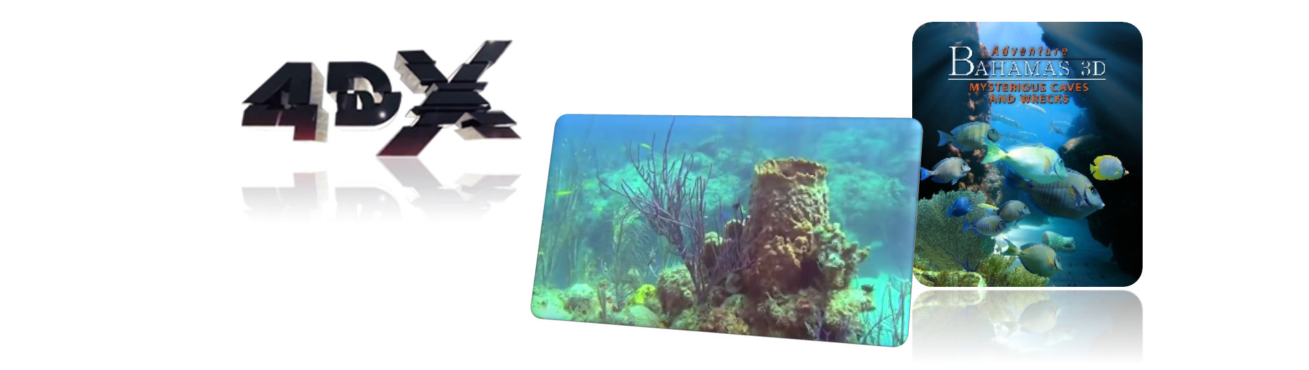

Bahamas 3D is an amazing product that will woo the tourist market. Atavus Group has already begun initiatives with the Ministry of Tourism about the project. The Government of the Bahamas is very excited about this unique opportunity to promote the Bahamas in 40 minutes.

Not to be outdone, Atavus has also begun discussion with the Ministry about producing an IMAX movie based on the Bahamas and its rich culture.

The Bahamas was also feature in travel magazines in a negative light concerning lack of entertainment options for tourist. IMAX’s Hollywood blockbusters will also be a vital part of the tourist experience. IMAX is the preferred way Americans and Canadians love to watch .Due to the limited time of the theater release window; movie buffs aren’t going to miss their favorites in the premium format

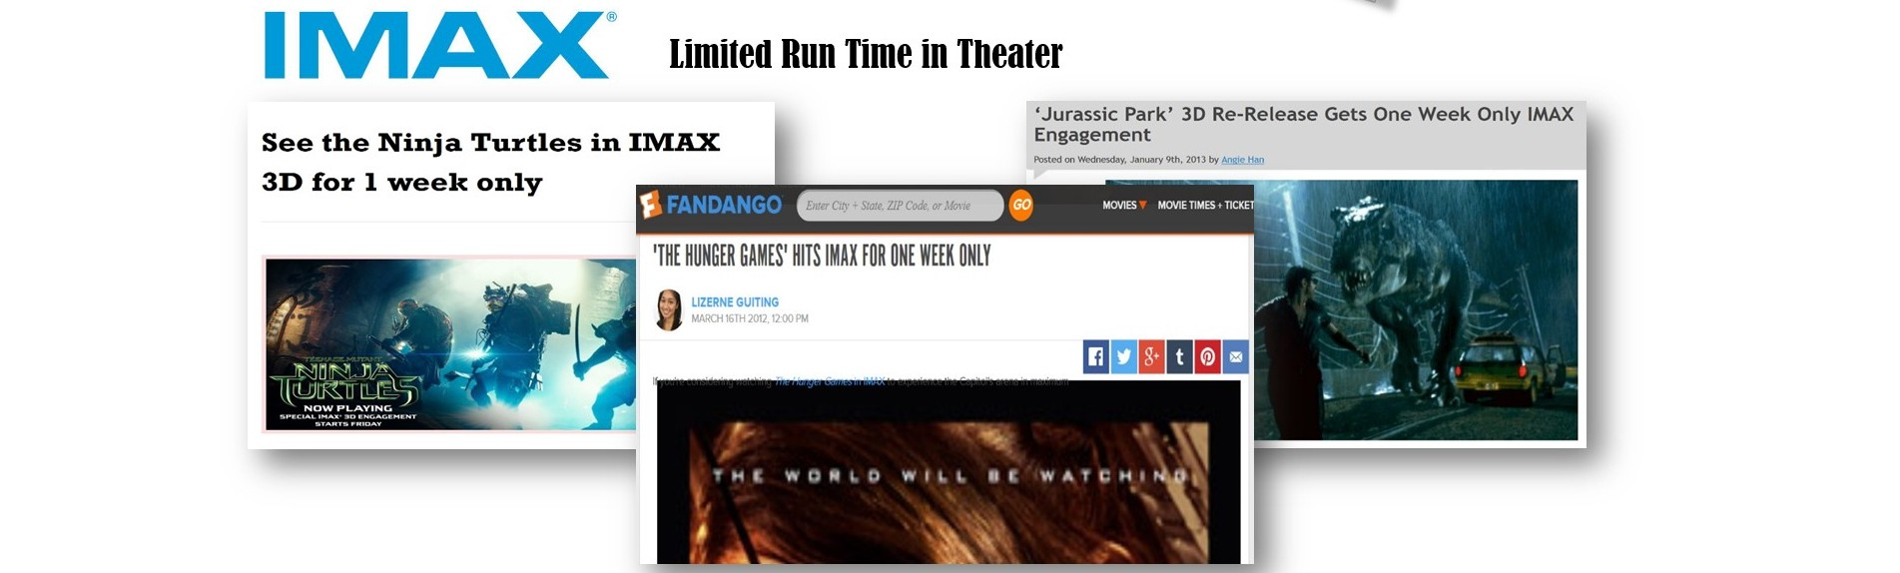

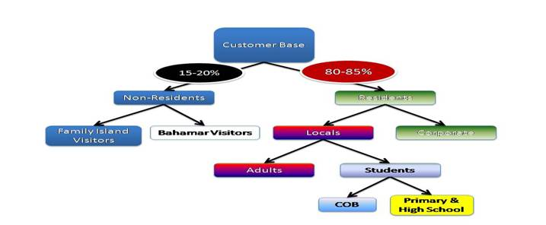When consideration of the cheaper Bahamian ticket prices is taken into account, the proposition becomes even more attractive. That being said the tourist customer base is not a large component of the overall projects:

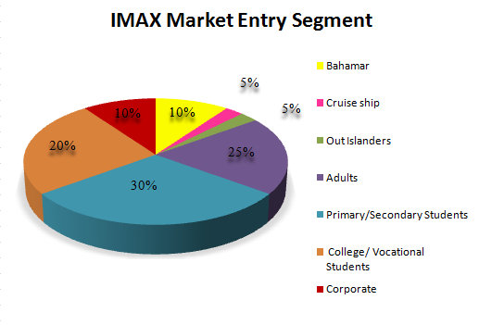

**1 %**

**1.5%**

**7.5 %**

**Lessons for the Future**

***Reason 5 to Invest:***

*The foundation for the long term sustainability of Showcase with IMAX is in place; hence the investment risks will be minimized.*

**A. The Customer Base of the Future**

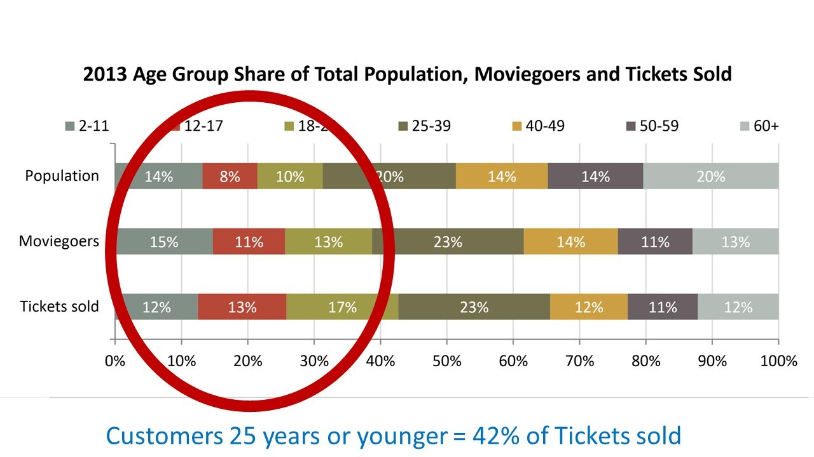The Motion Picture Association of America broke down the global movie-going population:

Why is this important in the Bahamas?

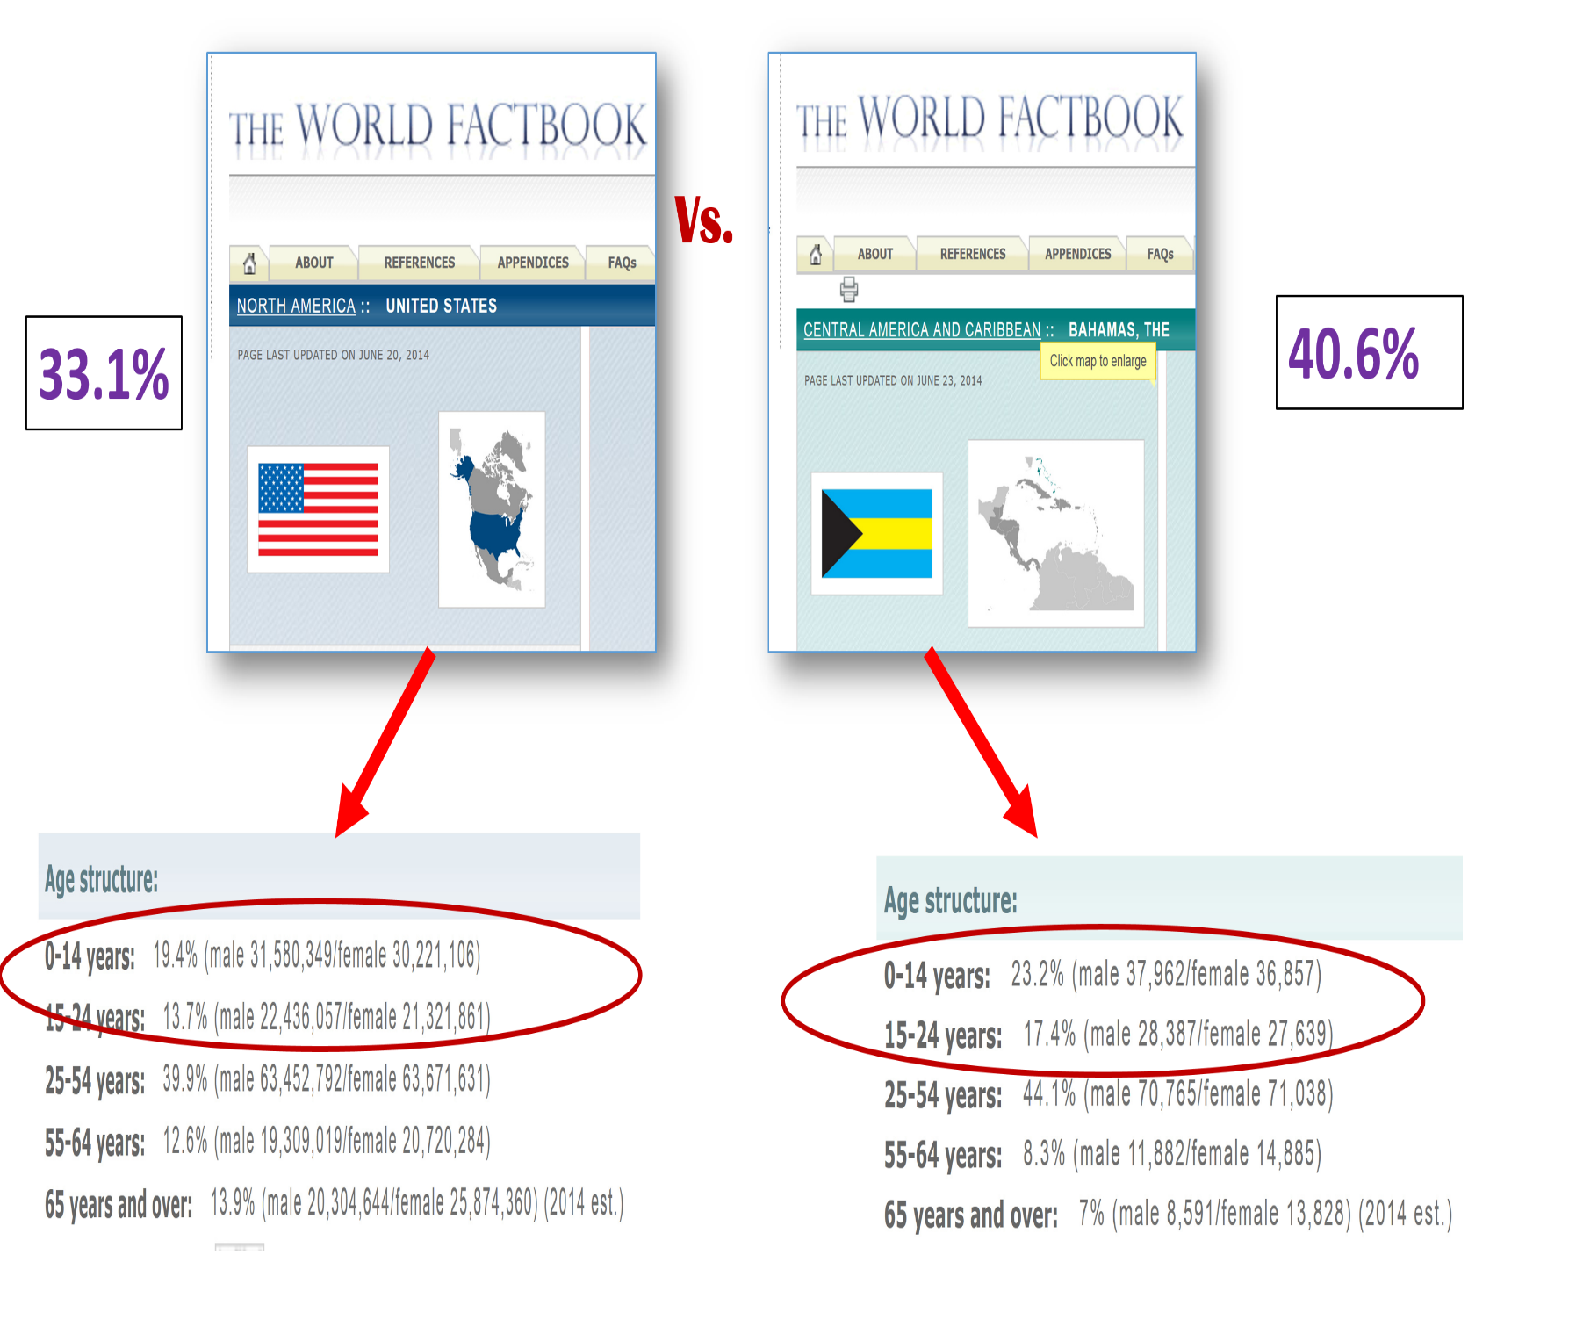An amazing 40 % of the country is below the age of 25 years compared to only 33% in the U.S.

This number is the highest percentage in the world. The cinema will have a steady stream of its core audience for years to come.

This also means that having other age appropriate content is even more important. With more than 23% of the population under the age of 14 and an average age of first birth amongst Bahamian women at 26, the population is geared towards child based entertainment.

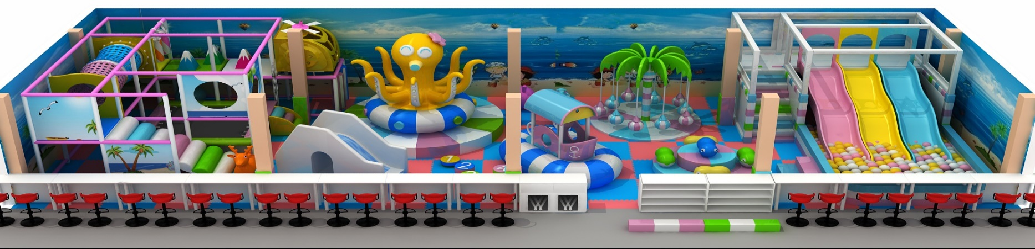Currently there are **NO kids play centers** for Bahamians. There is only one for tourists at their hotels.

This is why Atavus knows the Soft-Play center and the arcade, on the lower level of the facility, will be a huge revenue generator for years to come.

**B. The Future of Exclusive IMAX Early Releases**

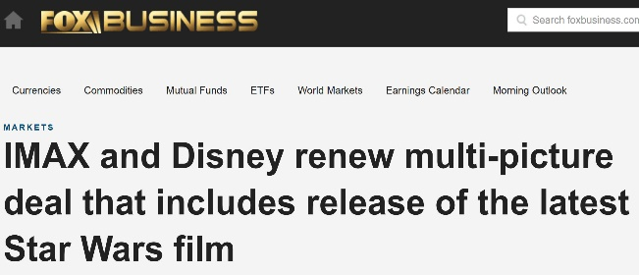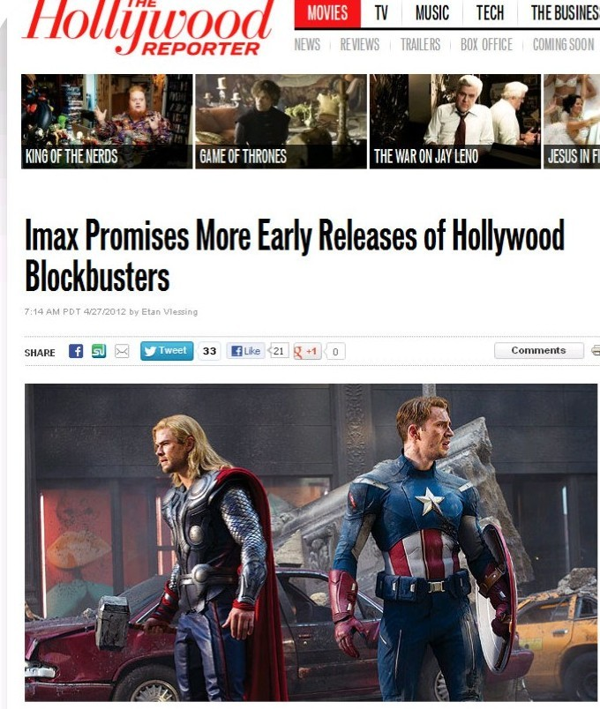IMAX promises more early release because the studios have extended their deals.

**C. Future of Technology in Cinema**

The top reason that Bahamian movie theaters have been supplanted in their monopoly was the arrival of new competitors with superior technology. This is what Showcase will do to Galleria in 2016.

Understanding where the global cinema industry is going is the key. Currently the top two technologies that will shape the next 5-7 years of the exhibition market are:

1. IMAX New Laser



**2. 4DX’s new product Screen X**

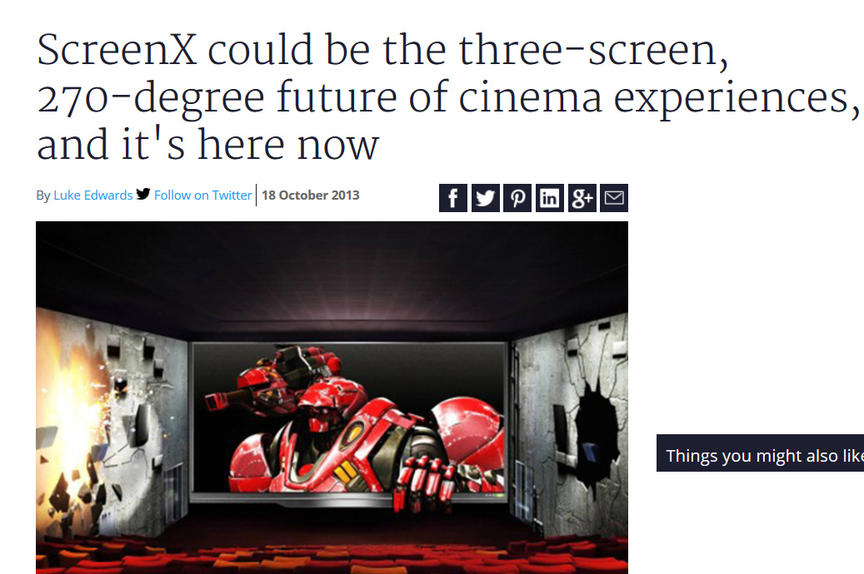

Both of these new technologies fall under the provision of Atavus’ Territorial Exclusive Agreements with IMAX and 4DX. This provides an important layer of financial and strategic insulation for the market.

However Atavus will continue to be vigilant in its search for other technologies to enhance the product mix.

Note: .Please reference Long Term Viability report at end of this section for more details.